**1.PERSONAL INFORMATION**

**Full Name:** Tran Gia Luat Ung  
**Gender:** Male  
**Date of Birth:** 17/03/1997  
**Student number:** 3779300  
**University:** RMIT  
**From:** CanTho city, Vietnam  
**Nationality:**VIETNAMESE  
**Language spoken:** VIETNAMESE and ENGLISH

**-Facts about my self:**

I am an honest man, love sport, basketball passion, like hangout with friends, and addict in travelling.

## 4. PROFILE

### My Results

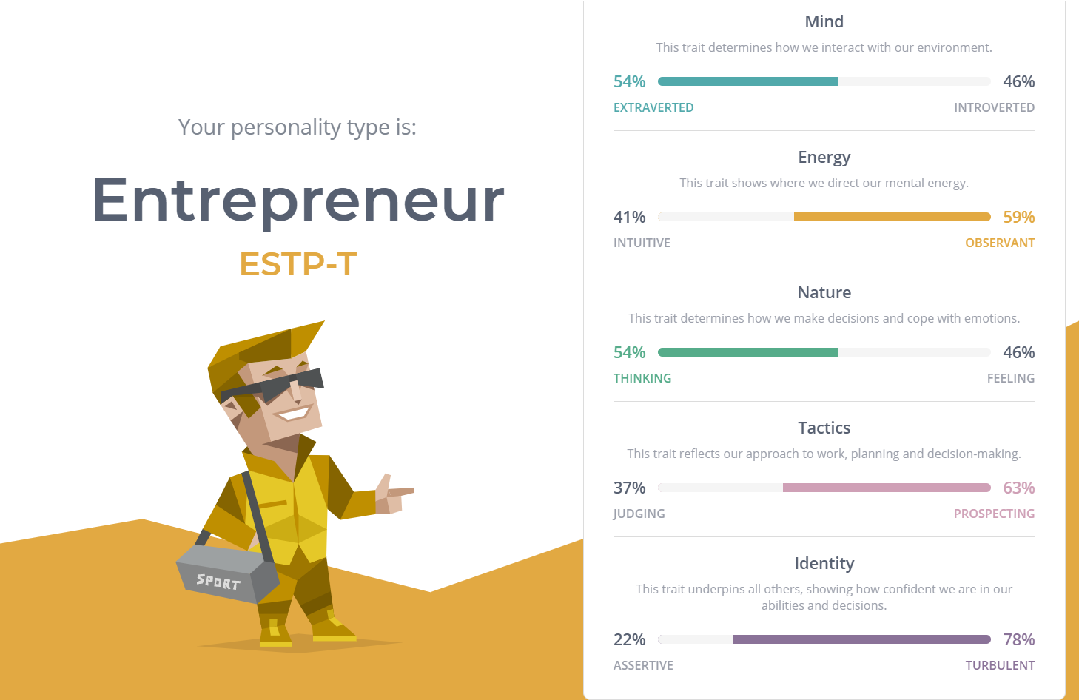

*Myers Briggs Test*

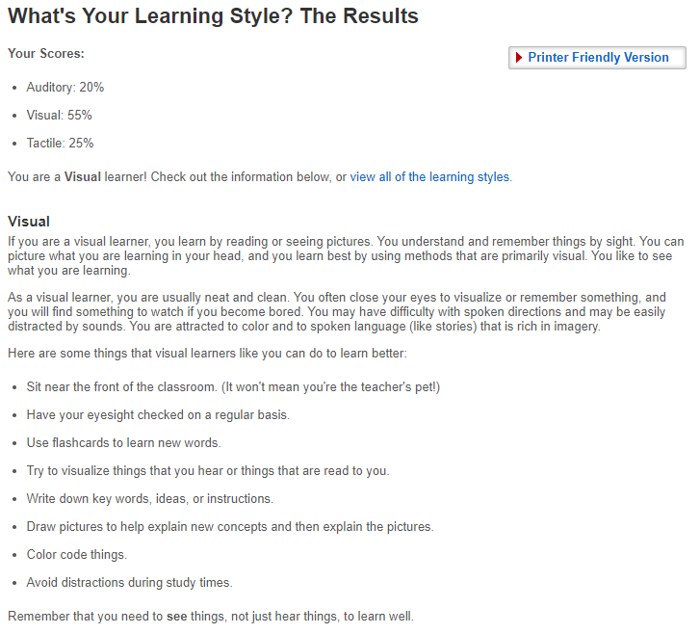

*Learning style Test*

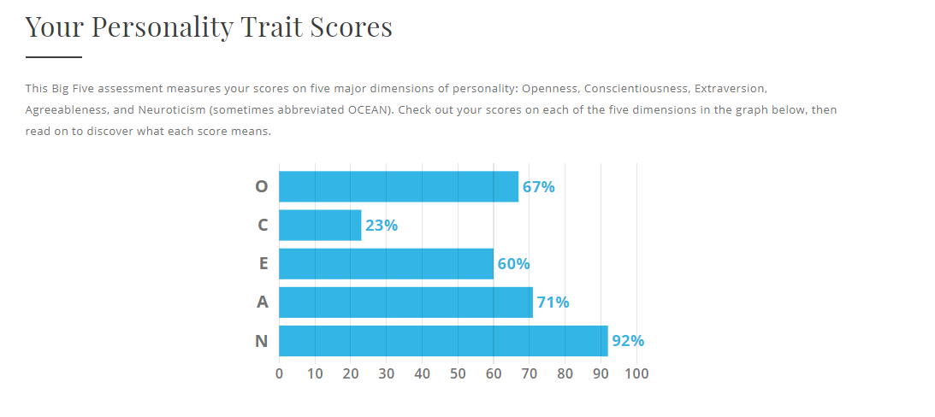*Big Five Test*